**SU Gate**

CCU101: COMMUNITY CONNECT PROJECT REPORT

***by***

**Nancy, Neeraj Rana, Prerna Sikarwar, Prince Bhardwaj, and Rahul Kumar**

180101202, 180101206, 180101230, 180101231, 180101244



Department of Computer Science and Technology

School of Engineering and Technology

Sharda University, Greater Noida, INDIA

November 10, 2020

**BONAFIDE CERTIFICATE**

This is to certify that this project report entitled **SU Gate** submitted to **School of Engineering and Technology, Sharda University**, is a bonafide record of work done by **Nancy, Neeraj Rana, Prerna Sikarwar, Prince Bhardwaj, and Rahul Kumar** under my supervision from **24 August 2020** to**10 November 2020.**

….…………….

….…………….

….……………

….……………

Place:

Date:

**Declaration by Author(s)**

This is to declare that this report has been written by me/us. No part of the report is plagiarized from other sources. All information included from other sources have been duly acknowledged. I/We aver that if any part of the report is found to be plagiarized, I/we are shall take full responsibility for it.

Nancy

180101202

Neeraj Rana

180101206

Prerna Sikarwar

180101230

Prince Bhardwaj

180101231

Rahul Kumar

180101244

**TABLE OF CONTENTS**

|  |  |
| --- | --- |
| **CHAPTER NO. TITLE** | **PAGE NO.** |
| **ABSTRACT** | **1** |
| **CONTENTS** | **xx** |

|  |  |
| --- | --- |
| **1. Introduction ..........................................................................** | **2** |
| **1.1 Android Operating System**.......................................... | **2** |
| **1.2Android Feature............................................................** | **3** |
| **1.3 Purpose ………….........................................................** | **4** |
| **1.4 Scope…………………...................................................** | **4** |
| 1. **Requirement Specification.….............................................** | **4** |
| 1. **System Tools………………………………………………** | **5** |
| 1. **Analysis …………..……………………………………….** | **5** |
| 1. **Design Introduction………………………………………** | **6** |
| 1. **Use case Diagrams……………………………………….** | **7** |
| 1. **Flowchart…………………………………………………** | **10** |
| 1. **System Testing……………………………………………** | **10** |
| 1. **Proposed System………………………………………….** | **12** |
| 1. **Features of this app………………………………………** | **13** |
| 1. **Module/working………………….……………………..** | **14** |
| 1. **Conclusion……………………………………………….** | **19** |
| 1. **References………………………………………………** | **20** |
| 1. **Role of developer……………………………………….** | **20** |

**ABSTRACT**

The Project 'Gate-pass Management System' is to record the details and various activities of the user. It simplifies the task and reduces the paperwork. In this project, we are reducing the paperwork which is done by giving the paper gate pass. We are providing the electronic version of the paper gate pass. We provide appropriate training to the user which suits their specific support has been provided at key points within the academic calendar. Admin is monitoring all the user and system. In this project, the only faculty is approving the user gate application if they want to allow students then the gate pass system is a pop-up on the guard system database. Training has been provided on a timely basis and they got trained as the Gate pass System is new and rolled out to their area of responsibility. At the moment we are in the very early stages, so it is difficult to put a specific time on thetraining, but we will keep people informed as plans are developed. The system is very user-friendly and it is anticipated that functions of the system are easily accessed by administrators, Faculties, students, and applicants.

**Introduction**

Gate pass is a mobile system to manage visitors in and out from a premise. It helps to keeps track of all visitors. In this security and monitoring has will be added. It eliminates the need for a manual register at the entry and exit. It keeps all the data in the cloud. Only you can access your data. It reports to trace is visitors in and out of tremies.

In modern times where security becomes more challenging in buildings and commercial complexes, residential societies find it mandatory to track visitors. In this case, guest management software such as Visitor is a perfect and smart solution to manage and track guests, daily workers, contract laborers, servants of residential complexes, apartments, housing colonies, or in other words society as a whole. During this pandemic, security becomes the main aspect of societies.

**Android Operating System**

Android is a software platform and operating system for mobile devices, based on the Linux kernel, and developed by Google and later the Open Handset Alliance. It allows developers to write managed code in the Java language, controlling the device via Google-developed Java libraries. There are over 300 million Androids in use and over 850,000 devices are activated every day. Android is one of the most used mobile operating systems with a market share of 48% and Over 400,000 applications available in the Google play store.

**Android Features**

User Interaction: Android Provides beautiful, attractive

and comfortable user interaction.

• Connectivity: Android supports different connectivity

technologies like Bluetooth, Wi-Fi, and WiMAX.

• Messaging: SMS, MMS, and android cloud to device

messaging framework is available in android operating

system.

• Web browser: Browser present in android operating

the system depends on web kit in the mix with Chrome's V8

JavaScript engine supporting.

• Java support: Most of the android applications are written

in java language but there is an absence of java virtual

the machine in the platform of that DVM is presented. DVM

is specially designed for android and battery-powered

mobiles.

• Multitasking: Android supports multi-tasking, which

provides the flexibility of running from one application to

another or running different applications simultaneously.

• Hardware Support: Android supports video or still

cameras, touchscreens, GPS, accelerometers, gyroscopes,

magnetometers, proximity and pressure sensors,

thermometers.

**Purpose:-**

The purpose of developing this application is to computerized the traditional way of managing the record of visitors.

**Gate pass** can be used to authorize the movements of humans, materials, and machines to or from the premises of the organization. It will help to monitor and track all the movements happening in an organization.

**Scope:-**

The Scope of the project is the system on which the software is installed, i.e. the project is developed as a mobile application, and it will work for particular tremies to manage the record of visitors in and out.

**Requirement Specification**

|  |  |
| --- | --- |
| **RAM** | 512 MB |
| **Hard disk** | 2 GB |
| **Processor** | 1.0 GHz |
| **Android Version(min)** | Kitkat |

**System Tools:**

Android Studio has been used as a development environment. Java and SQL are been used as programming and scripting languages.

**Analysis:**

Nowadays everything is modernizing and maintaining the record of the visitors is hard to maintain. This App will help the user to track and monitor the visitors and also easy to handle.

**The disadvantage of the present system:**

* Not user friendly: The present system not user friendly because data is not stored in the structure and proper format.
* Manual Control: All calculation of visitors is done manually so there is a chance of error.
* Lots of paperwork: maintaining the records of the visitors in the register, so lots of paper requires storing details.
* Time-consuming.

**Design Introduction:**

Design is the first step in the development phase for any techniques and principles to define a device, a process, or system in sufficient detail to permit its physical realizing. Once the seaware requirements have been analyzed and specified the seaware design involves three technical activities - design, coding, implementing, and testing that are required to build and verify the seaware.

The design activities are of main importance in this phase because, in this activity, decisions ultimately effacing the success of the seaware implements’ and its ease of maintenance is made. These decisions have the final bearing upon the reliability and maintainability of the system. Design is the only way to accurately translate the customer’s requirements into a finished seaware or a system.

Design is the place where quality is fostered in development. Seaware design is a process through which requirements are translated into a representation of software. Software design is conducted in two steps. Preliminary design is concerned with the transformation of requirements into data

UML Diagrams: Actor:

A coherent set of roles that users of use cases play when interacting with the use of` cases.

Use case: A description of a sequence of actions, including variants, that a system performs that yields an observable result of the value of an actor.

UML stands for Unified Modelling Language. UML is a language for specifying, visualizing, and documenting the system. This is the step while developing any product after analysis. The goal from this is to produce a model of the en'' es involved in the project which later needs to be built. The representation of the one's that are to be used in the product being developed need to be designed.

# **USE CASE DIAGRAM:-**

Use case diagrams model behavior within a system and helps the developers understand what the user requires. The sick man represents what’s called an actor.

Use a case diagram can be useful for getting an overall view of the system and clarifying who can do and more importantly what they can’t do.

The use case diagram consists of use cases and actors and shows the interaction between the use case and actors.

* The purpose is to show the interactions between the use case and actor.
* To represent the system requirements from the user’s perspective.
* An actor could be the end-user of the system or an external system.

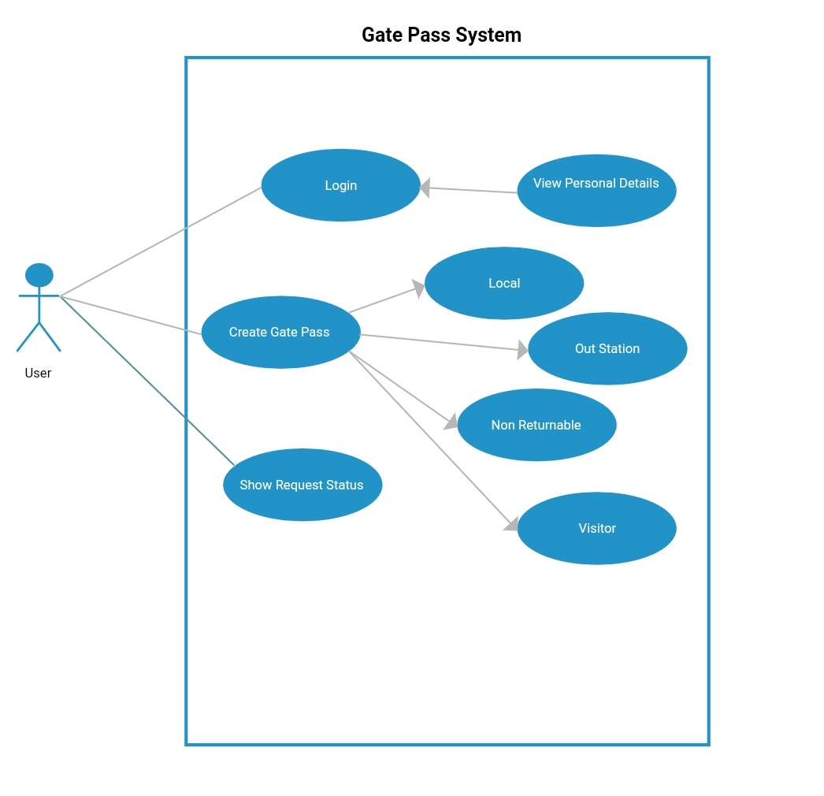

# **CONTINUE....**

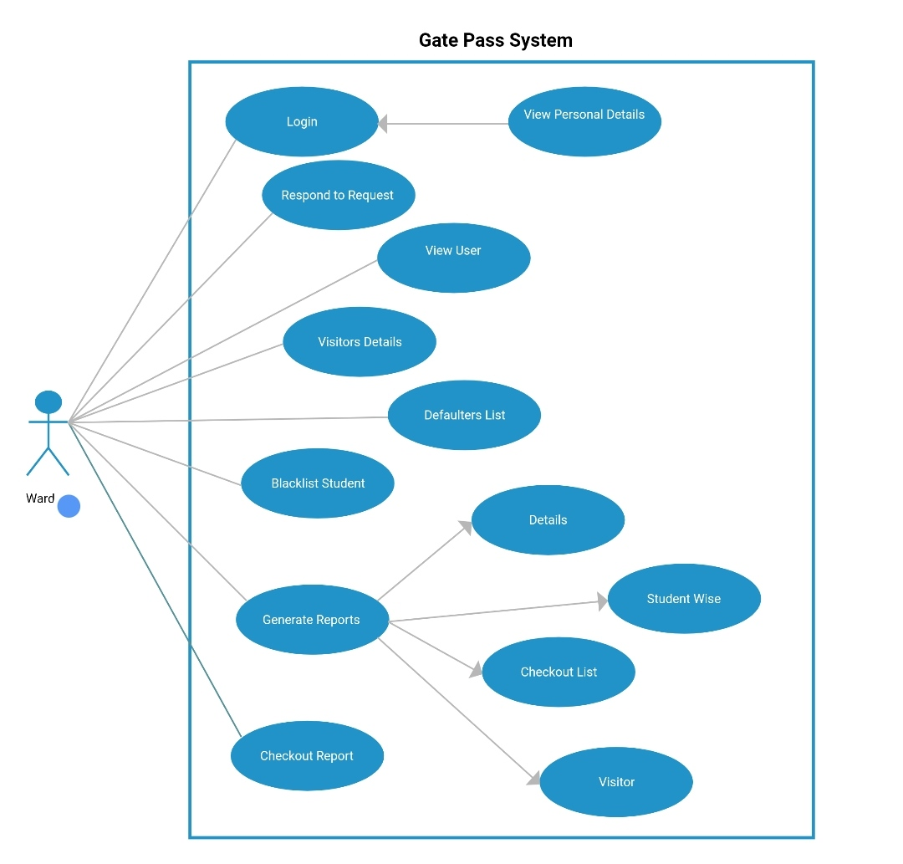

**FlowChart:-**

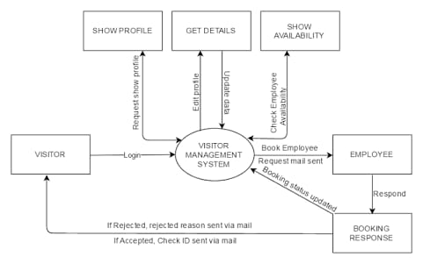

**System Testing**

The goal of the system testing process was to determine all faults in our project. The program was subjected to a set of test inputs and many explanations were made and based on these explanations it will be decided whether the program behaves as expected or not. Our Project went through two levels of testing.

1. Unit testing  
2. Integration testing

**UNIT TESTING**

Unit testing is commenced when a unit has been created and effectively reviewed. To test a single module, we need to provide a complete environment i.e. besides the section we would require

* The procedures belonging to other units that the unit under test calls
* Non-local data structures that module accesses
* A procedure to call the functions of the unit under test with appropriate parameters

**1. Test for the admin module**

* **Testing admin login form-**This form is used for the log-in of the administrator of the system. In this form we enter the username and password if both are correct administration page will open otherwise if any of the data is wrong it will get redirected back to the login page and again ask the details.
* **Report generation:** admin can generate a report from the main database.

**INTEGRATION TESTING**   
In the Integration testing, we test the various combination of the project module by providing the input.   
The primary objective is to test the module interfaces to confirm that no errors are occurring when one module invokes the other module.

**PROPOSED SYSTEM:-**

* The Objectives of creating this system is to reduce the paperwork and to maintain the document in electronic form.
* Accurate maintenance of accurate and gate usage.
* To remove the duplicity of the pass and allow the verified visitor to cross the premises.
* In the earlier system, there were a lot of duplicities done by the visitors which are going to be removed by using this system.

**FEATURES OF THIS APP:-**

# **Smart Scheduling:** Schedule people in an orderly manner to enhance operational processes of the organization and also enhance the productivity.

# **Identify Visitors:** Visitor management system record visitor check-in identities with their pictures & save them for further use

# **Monitor Visitors:** Effective monitoring of user and waiting duration.

# **Smart Notifications:** Security gate pass app notifies the host about their visitor arrival by email & SMS alert with visitor details and timings.

# **Accurate In & Out Time Recording:** Security gate pass app records accurate in & out visitor timings to optimize organizational processes.

# **Real-time Reports:** It Generate real-time web-based reports which will be accessed on the fly.

**MODULE SNAPSHOT/WORKING**

**Admin Module:-**

Admin module is used by the Administrator or the Admin of the system who has the authority of the system who has the authority of the system. He /She may have the authority to keep an eye on the system and check whether the system is working properly or not. The Admin even has the authority to enable or disable the unauthorized user from the system.

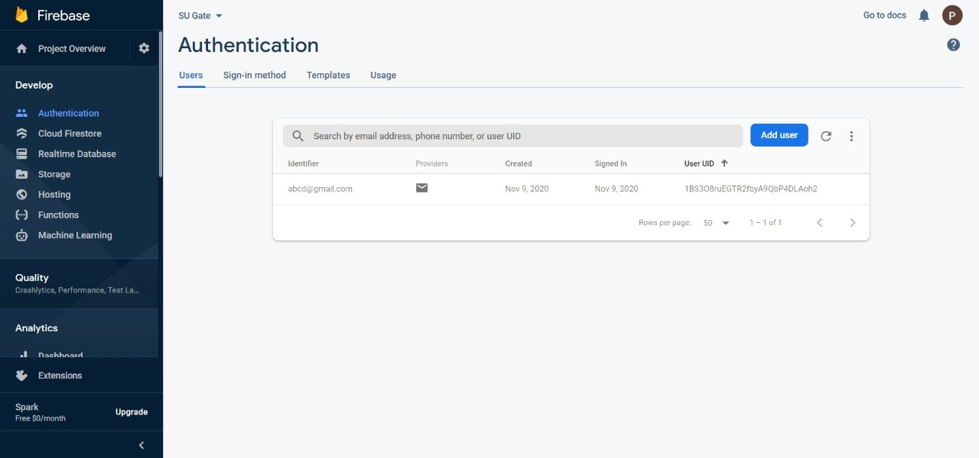

**User Module:-**

# In this module, the authorized user may allow the legal visitors to leave the premises. If and onlu if the visitor havinf the legal gatepass issued by the user.

**Here I present some demo shots taken to better explain my application:-**

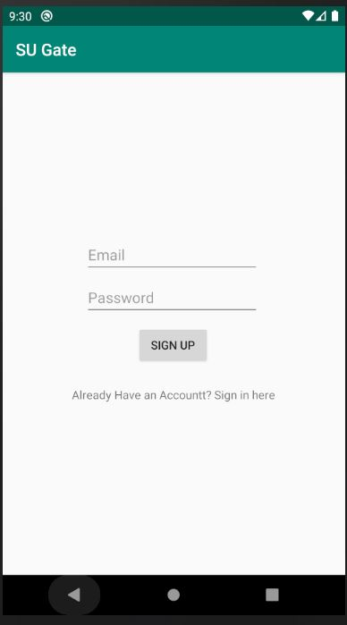

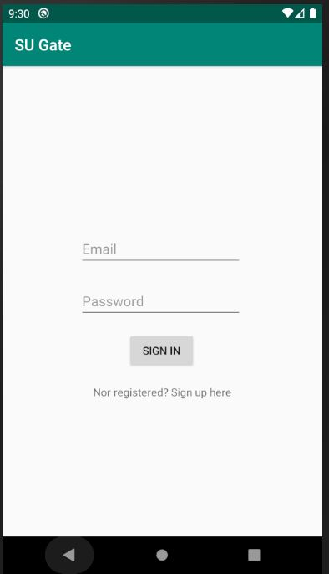

* **This is how our home page will look like after sign up:-**

**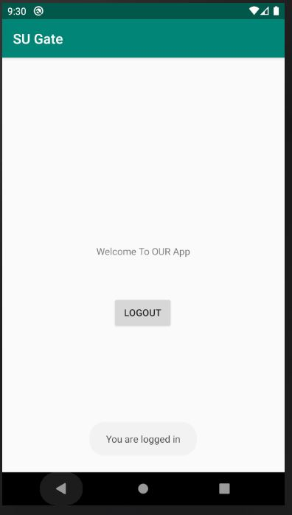  
For storing the Login, and SignUp data, Firebase is used:**



**CONCLUSION:**

In this report, Therefore the offline gate pass system using department effective tools which can be used to a great extent. The system is portable and can be easily installed and used in the department. Using this application proxy is completely avoided with a pure software approach. It will reduce the time, effort, and resources such as paper for both parties involved in the process. Also, it will eliminate the tedious work of the societies of maintaining different gate pass papers.

The Application was designed in such a way that future changes can be  
done easily. The following conclusions can be deduced from the development of the project.

• Automation of the entire system improves productivity-

* It provides a friendly graphical user interface which proves to be better when compared to the existing system.
* It gives appropriate access to the authorized users depending on their permissions.
* Updating of information becomes so easier.

The System has adequate scope for modification in the future if it is   
necessary.

**References**

-> Android Studio Tutorial from[www.udemy.com](http://www.Udemy.com)

->[www.wikipedia.com](http://www.wikipedia.com)

-> Google.

**Role of developer**

**Nancy:** Worked on backend using Firebase and and Android Studio.

**Neeraj Rana:** Worked on frontend using Firebase and and Android Studio.

**Prerna Sikarwar:** Dealt with the database creation.

**Prince Bhardwaj:** Worked on frontend, and modules using Firebase and Android Studio.

**Raahul Kumar:** Worked on module creation.